Compostable
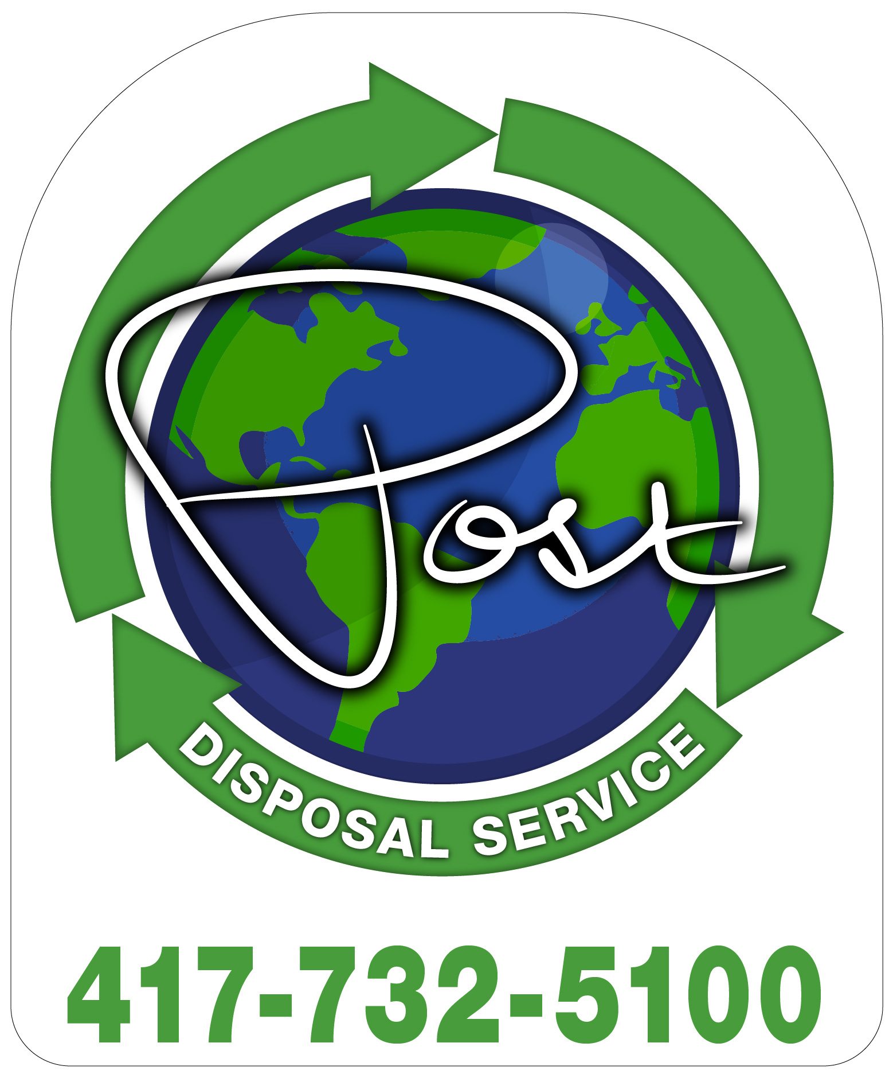

Food Residuals

• Pre & Post-consumer Food Waste
• Preparation Waste
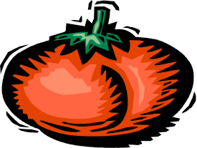

• Meat

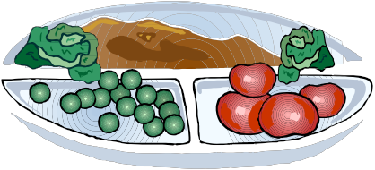

• Fruit
• Vegetables

• Eggshells
• Coffee Grounds

Paper Products
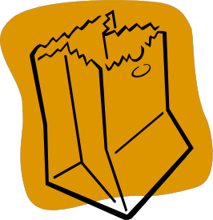

• Plates, bowls, cups
• Napkins, Paper towels
• Paper trays, liners
• Milk cartons
• Paper Sacks
• Waxed Cardboard and Paper
• Cardboard Boxes

Non-Compostable

Plastics / Styrofoam

• Bags and Liners
• Forks, Knives, Spoons

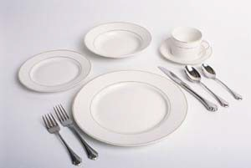

• Plates and Containers
• Cups, Lids, Straws
• Bottles

Other
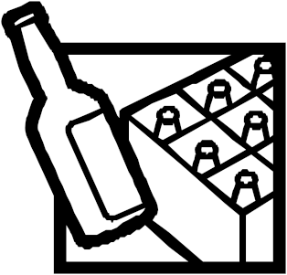

• Aluminum Foil
• Foil Wrappers

• Metal/Aluminum Cans
• Glass Bottles

• Ceramic Plates
• Metal Knives, Forks and Spoons

